Digital Signatures – Main Types & How They Work with Blockchains

Electronic signatures, or simply put, e-signatures, are a form of digital data that is linked to another electronic form of data. They work as virtual yet legal and recognizable handwritten depictions of your name. More and more people use e-signatures to prove their identity. In today’s post, we will discuss the main types of digital signatures, their connection with the Blockchain industry, and their main advantages.



## Types of Electronic Signatures

Basically, an electronic signature is a [virtual identification](https://ec.europa.eu/digital-single-market/en/trust-services-and-eid) that enables secure transactions. There is more than one type of e-signature out there. Below, you’ll find the main [types of electronic signatures](https://www.validatedid.com/vidsigner/).

### a. Simple Signatures

These are basic signatures that **don’t have special attributes**. With them, you can quickly sign any documents without the need to register. Still, this type of authentication has its limits. For starters, your identity **cannot be verified only by opening the signed document**. Simply put, the person that initiates the action must apply a hand-signature mark on a file. This way, the document will be protected by a cryptographic stamp. This signature may be simple but it remains powerful enough to ensure data integrity.

### b. Advanced and Qualified e-Signatures

Both these signature types are recommended by specialists as being the **safest** methods to ensure your files’ privacy and offer an **accurate trace** of the person that has signed them. They use unique signing keys which are different from one signer to the other. Experts call them digital signatures and they avoid using the term “e-signature” like in the case of basic stamps. **Private signing keys** are also good because they ensure non-repudiation, not to mention that they show the exact individual who signed the file.

### c. Click-to-Sign Signatures

There are several different forms of click-to-sign signatures such as *e-squiggles, typed names, tick boxes, and scanned images*. These are **simple and convenient** forms but they won’t offer cryptographic protection to your document. In other words, they **aren’t strong and safe enough**. People with wrong intentions can easily copy them on another document.

## Digital Signatures & Blockchains

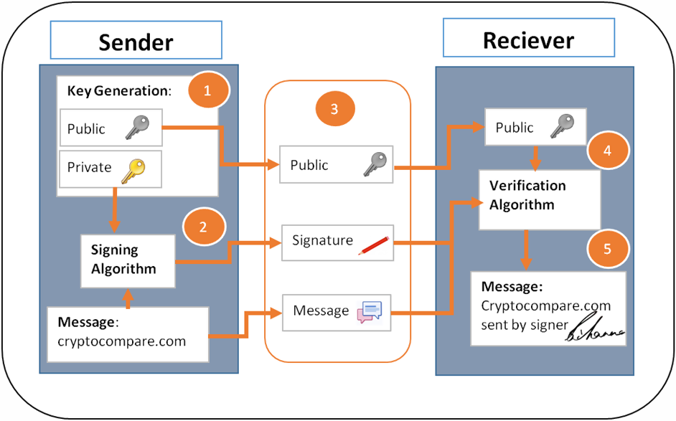

One thing that has gained a lot of popularity lately is the [new Blockchain-based technology for digital signatures](https://www.validatedid.com/). Those stamps that are powered by Blockchain are better and more effective. Due to the use of this new technology, **you won’t need expensive certificates anymore**. The somewhat natural evolution of electronic signatures includes Blockchains as well. This will let people know whether or not hackers or some other party has been tampering with the data.

With Blockchain-powered signatures, you can **authenticate any object in the digital environment**, add additional data in a secure way, verify the object without letting others access it, and do plenty of other useful actions.

Instead of using the current public keys to encrypt a document, Blockchain allows for the use of private keys which are significantly more secure. After all, cybersecurity has been revolutionized by this system. Moreover, the aforementioned system enables users to **include multiple signatures**, timestamps, and even fingerprints in the same file. In conclusion, all these things (electronic signatures, Blockchain, and [hashing](https://en.wikipedia.org/wiki/Hash_function) are all connected, and, in their most effective form, they could not exist one without the other).

## Why Do You Need to Use an e-Signature?

[Digital signatures](https://en.wikipedia.org/wiki/Electronic_signature) provide someone’s identification in both an accurate and secure manner. This way, two parties can **safely complete transactions, share documents**, etc. Qualified digital signatures are created using electronic certificates which are encrypted with a special security device. All businesses should use electronic identifications such as these. The reasons and benefits are quite simple:

* They provide a **higher security** level to all your documents;
* All those involved in a transaction or agreement will be able to keep track of all the information that’s shared between parties;
* These tools are easy to use and **highly intuitive**;
* It’s a convenient solution to **remote authentication**;
* In terms of costs, e-signatures are much more effective compared to their traditional counterparts.

## Bottom Line

Bringing it all together, electronic signatures are a must if you want your files to remain secure. If you’re looking for a higher level of security, you should pair your signatures with Blockchain systems. Finally, pay attention to what type of timestamp you choose to use because some are more effective than others.

Images sources: [1](https://www.pexels.com/photo/closed-up-photo-of-man-in-black-blazer-facing-tablet-1059109/), [2](https://ro.pinterest.com/pin/446560119287068247/)